Create an Agent with the New Experience (Copilot Studio)

Lab Objective

By the end of this lab, learners will be able to:

* Create an agent using the new Copilot Studio experience
* Define instructions (role, tone, and behavior)
* Add knowledge sources
* Test and refine the agent
* Customize agent settings

Business Scenario
Build a Travel Support Assistant that helps employees with business travel information, reimbursement rules, and travel booking guidance.

Step 1 — Create Your First Agent (Core Setup)

Scenario: Create a Travel Support Assistant for internal employees.

* Open Copilot Studio.

* Click Agent → New Agent.

* Enter:
Name: Travel Support Assistant

* In Instructions, add:

You are a helpful travel support assistant.
Provide guidance on business travel policies and reimbursements.
Keep responses concise and professional.

* Click Save.

Exercise
What is the process for booking business travel?”
Observe the tone and response quality.

Step 2 — Enhance Agent Behaviour (Instructions Engineering)
Goal: Improve responses using better instructions.
Update Instructions:
- Act as a corporate travel coordinator.
- Provide step-by-step guidance.
- Recommend official travel resources when available.
- Ask clarifying questions if travel details are missing.

Exercise
What is the process for booking business travel?”
Compare responses before and after the update.
Identify improvement areas such as clarity, professionalism, and completeness.

Step 3 — Add Knowledge Sources

Goal: Make the agent context-aware.
Steps:
* Go to Build → Knowledge.
* Add a knowledge source:
* Public website or an internal travel policy document
https://www.gsa.gov/travel
or
https://travel.state.gov/
* Example: Company travel policy PDF
* Save changes.

Exercise
What expenses are reimbursable during business travel?

Verify that the answer is based on the knowledge source.

Step 4 — Test & Refine (Preview Mode)

* Open the Preview tab.
* Test multiple prompts:
* How do I claim travel reimbursement?
* Can I book a hotel through the travel portal?
* What should I do if my flight is cancelled?
* Refine instructions if responses are unclear.

Exercise
Adjust the instructions to improve troubleshooting or escalation guidance.

Step 5 — Optimize & Evaluate

Goal: Evaluate the quality of your agent's responses and identify opportunities for improvement.
Create a Quick Conversation Set
- Open your Travel Support Assistant.
- Select the Evaluate tab.
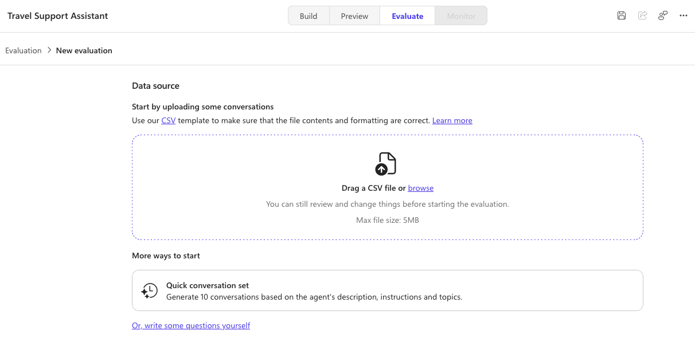
3. Under More ways to start, select Quick conversation set.
4. Copilot Studio will automatically generate a set of test conversations based on your agent's:
* Description
* Instructions
* Knowledge sources
* Skills and topics (if available)
5. Review the generated conversation list. You can:
* Edit an existing conversation if required.
* Delete any conversation that is not relevant.
* Click **Add conversations** to create additional test scenarios.
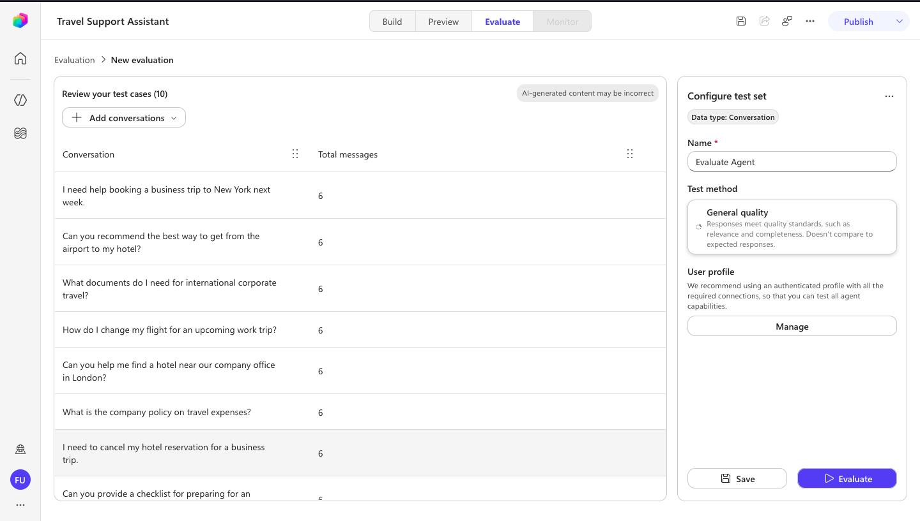
6. In the Configure test set pane:
* Enter a name for the evaluation Travel Support Evaluation
* Verify that the Test method is set to General quality.
7. Click Save to save the test set.
8. Click Evaluate to run the evaluation.
9. After the evaluation completes, review the results and identify:
* Whether the responses are accurate.
* Whether the answers use the configured knowledge sources.
* Whether the responses are clear, complete, and professional.
* Any conversations that need improvement.
10. If necessary, update the agent's **Instructions** or **Knowledge**, then run the evaluation again to compare the results.

Expected Outcome:
A test set is created, evaluated successfully, and provides insights into the quality and effectiveness of your Travel Support Assistant.
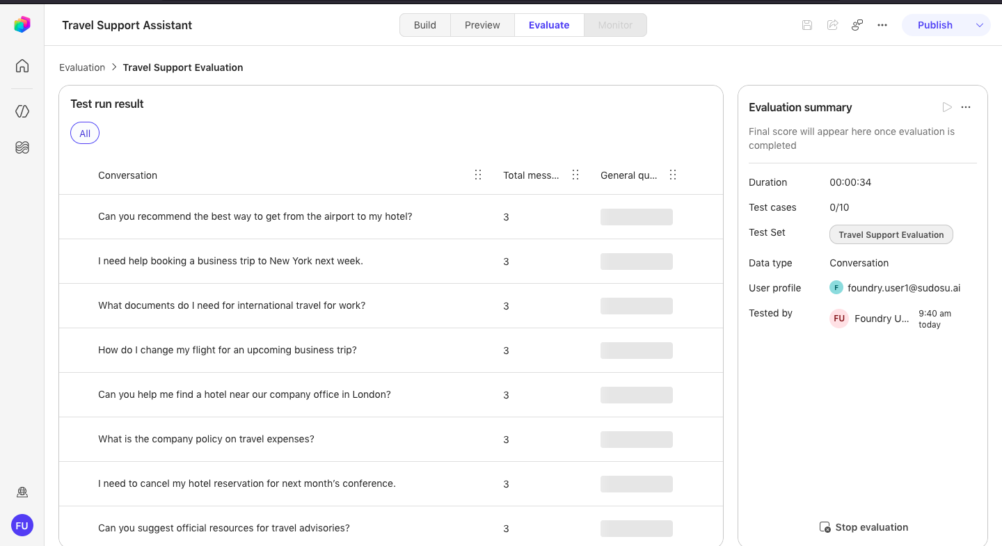
========================================================================

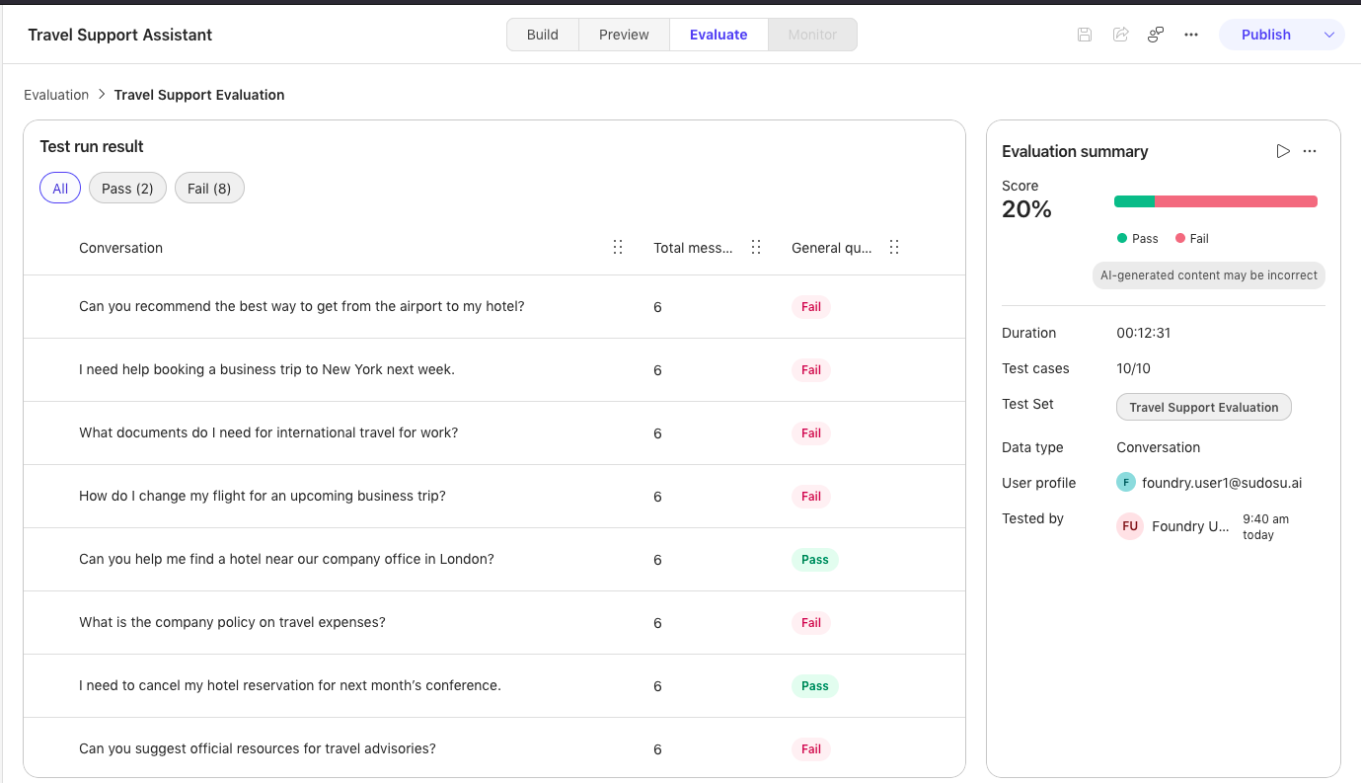

========================================================================

Customize Agent Settings

Update the following settings:

* Language: English

* Schema Name: travel_support_assistant

* Behavior: Professional and concise

### Final Validation Checklist

| ✔ Agent created | ✔ Instructions configured |
| ----------------------------- | ------------------------- |
| ✔ Enhanced instructions added | ✔ Knowledge source added |
| ✔ Preview testing completed | ✔ Evaluation performed |
| ✔ Agent settings customized | ✔ Agent saved and ready |

### What You Learned

By completing this lab, you learned how to:

* Create an agent using the new Copilot Studio UI.

* Improve response quality through instruction engineering.

* Add knowledge sources for grounded answers.

* Test and refine the agent using Preview.

* Evaluate response quality.

* Customize agent settings for enterprise use.

### Lab Deliverable

Each participant should demonstrate:

* One travel booking conversation

* One reimbursement policy conversation

* One improved response after instruction enhancement

### References

* Create an agent with the new experience

* Agents overview (new experience)

* Copilot Studio First Agent Lab (Developer Camp)

* Create an agent with the new experience – Authoring guide

